North Lancashire
Annual Report

2017-18

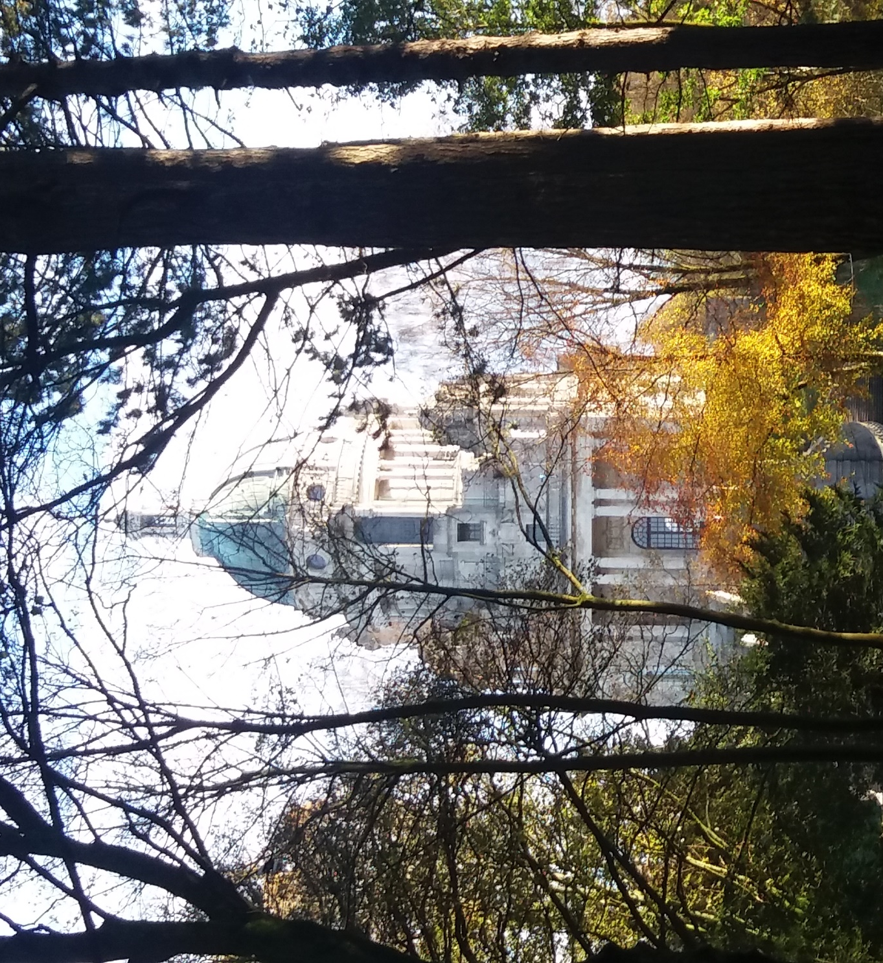

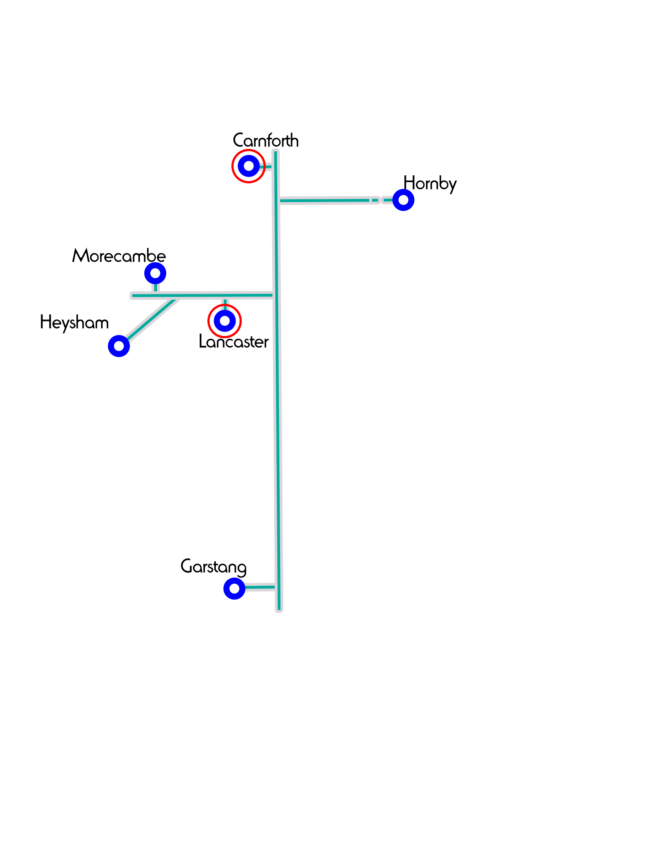
Chair’s report
Recent surveys show that the vast majority of children in the UK are not connected to any church. Headlines continue to remind us of the pressure and stress many teachers/pupils feel and the rising numbers of young people with mental health issues, eating disorders, etc. If we are serious about reaching this generation, and being salt and light to them, we must continue to pray for our schools and become actively involved in making a difference.
That’s why I am so thankful for all that our wonderful team of school’s workers do throughout the year to bring the Good News of Jesus to our schools. This last year has been another amazing year as they have taken God’s Word into Primary Schools and High Schools throughout the region with assemblies, lessons, and clubs. Not to forget church visits and all sorts of other networking events.
As we come to the end of another year, it is an opportunity to look back and give thanks for all that God has done but we must also look forward and rise to the challenge, as believers and churches, of making Jesus known in our schools. I also want to say a huge thank you to all our faithful prayer and financial supporters who enable this valuable work to continue and flourish. God bless you for your partnership in the Gospel.

Mark Johnstone
(Chair of Support Group)

Rev Mark Johnstone
(Chair of Support Team)

Finances

Income and Expenditure - For the Year ending 31st December 2017
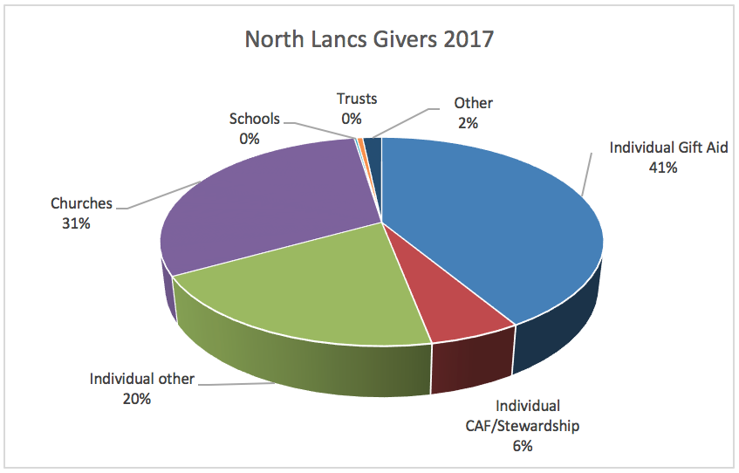
Income | 2017 | 2016
Church Pledged Gifts  Individual Pledged Gifts  Tax Recovery  Miscellaneous Gifts  Local Bank transfer  Total income | £18,082  £41,738  £5,851  £1,404  -  £67,075 | £12,157  £36,489  £6,414  £1,762  -  £56,822

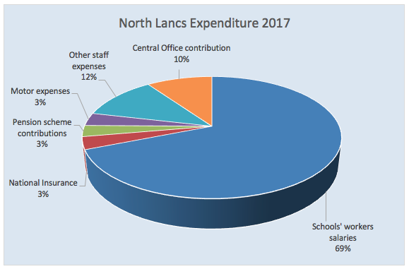
Expenditure | 2017 | 2016
Total Expenditure | £76,141 | £57,718

Balance Sheet as at 31st December 2017

Capital Account | 2017 | 2016
Accumulated Fund | £27,399 | £28,294
Net Surplus for the year | £-9,066 | £-895
Balance | £18,333 | £27,399

Work in Schools

This year we… | Primary work | Secondary work
visited schools | 46 | 6
Delivered assemblies (collective worship) | 65 | 16
of which were delivered by our puppet teams | 26
Taught lessons | 171 (+ weekly fruit of the Spirit and Bible Challenge lessons) | 41
Supported lunchtime/after school clubs | 5 (weekly) | 4
Independent school clubs | 12
other stuff …such as Christmas/Easter roadshows, Prayer spaces…etc | Prayer spaces,  Walk Through Easter (7 schools) | 2 Crème Egg Quest lunchtimes, Spirituality Days, 2 Listening Services,

Our Story

This year we have seen God move in amazing ways, enabling us to do more and speak out the truths of His word in schools across North Lancashire. We have coped with change, moving office from Lancaster to Torrisholme, and losing Rachel as she became a Mum; we have coped with challenges, not least the mind-bending requirements of GDPR; and we have connected with more churches and are ever grateful for their support as we have met with children through lessons, clubs, assemblies and much more.
We have become more aware of the needs of young people, particularly those struggling with mental health issues, but also those who just need someone to talk to, and we are still working out how God want us to support those in need.
We have also begun trying to focus more on regions within North Lancashire, increasing our communication with supporters and churches, although this is an ongoing task. One area that has really taken shape this year is Garstang, partly helped by increasing contact with local schools, and also some committed pray-ers. We hope to see more of this across North Lancs in the years to come!

Area Support Group: | Area Staff:
Mark Johnstone (Chair), Steven Hewitt, (standing down)  Jane Callow,  Graham Pollitt,  Alex Fearnhead | Debbie Green  Primary  debbie.green@niscu.org.uk | Diana Stopczynski  Primary  diana.stop@niscu.org.uk | Jonny Bayes  Secondary  jonny.bayes@niscu.org.uk
 | Sarah Dodd  sarahjdodd@talktalk.net | Lou Mosey  louisemosey@gmail.com | Rachel Carling  Worked for niscu up till April 2018

Further information
If you would like to receive our weekly prayer bulletins or periodical newsletters, please email jonny.bayes@niscu.org.uk
If you would like to see what we do each week, then visit our website www.niscu.org.uk/nlancs and you will see our diary.
If you would like to support us financially, either go to https://niscu.org.uk/home/giving/, or email ruth.robinson@niscu.org.uk.

Debbie Green

I’m grateful for
- Teachers, TAs and parents who volunteer their time to run clubs
- 46 schools who invited us in to take lessons and assemblies
- 19 churches this year who asked us to share our stories
- A new large office at Torrisholme Methodist Church (pop in sometime!)

I’m challenged by
- The funding needed for our team and now especially our CEO’s role
- Finding ways to thank and bless our awesome team and volunteers
- The administrative task of communicating all this to so many churches
- The vast possibilities in schools and the pastoral needs of pupils and staff

I feel blessed when
- Children share their love for Jesus with their classmates
- I see churches looking for ways to bless their local schools
- I have the privilege of sharing the Bible with children
- I play kazoo alongside Rachel or pop a pair of wings onto Jonny (assembly moments!)

A praying friend shared an amazing verse with me last week, “All your sons will be taught by the LORD, and great will be your children’s peace.” Isaiah 54:13. Can you imagine it? In today’s society where the wellbeing of children often hits the headlines, we have the LORD offering His teaching and peace – something that brings healing and is eternal.

Of the 25 schools I personally have visited this year I have seen some wonderful reactions to God’s Word. Through lessons, RE Days, Prayer Spaces, teacher-training, Puppet shows, Walk Through Easter events, student training at Capernwray and University of Cumbria, writing a new Bible Challenge for Blackburn Diocese and eating and praying with school staff at Encouragement Evenings I get to see God bring His Word and His peace in so many situations.

Some emotional moments stand out – tears on the face of a teacher at our meal as they are told how wonderful they are; the little boy who sat back and smiled as his class named him as a friend of Jesus; the delight of a class bouncing round the room to Rend Collective’s “Create in me” song; the concern of children who hear for the first time that in some countries people are put in prison because they are Christians and refuse to deny Jesus.
God has so much to offer our schools – He is asking the church to be His channels of teaching and peace. What an honour.

Diana Stopczynski

I have had another very enjoyable year working with the NISCU teams in North Lancs and South Lakes and continue to build relationships with both teachers and children in schools. In North Lancs I have continued taking Christianity lessons in to the primary schools which is where I think I can be used best. I also lead clubs at Skerton St Luke’s, Grosvenor Park, Lancaster Road and Trumacar and support LBC Jam Club on the Ridge. These clubs provide a safe environment for children to learn more about God in an exciting and interactive way.

Highlights
I again enjoyed being part of the Christmas Puppet Roadshow which visited 26 primary schools in the area. This provides brilliant opportunities, especially in community schools to take the gospel to thousands of children..
The ‘Walk Through Easter’ sessions we took to various churches provided another special and blessed time when children who visited were impacted by the Easter Story. When they shared their worries with us on paper leaves at ‘The Garden’ it certainly opened my eyes to the difficult situations they live with day to day and prompted me to pray and ask God to show us a way we can help provide support to these vulnerable children.
When I was leaving a school recently a little boy said to me, “I love you. You’re special, just like Jesus.” What a wonderful confirmation of taking Jesus in to schools so that children learn to understand how very special He is.

Jonny Bayes

This year has been one often requiring patience. After feeling like I hit the ground running in my first year, I have had fewer responses from schools than I expected and in some cases found a closed door, which has been challenging, especially when I know the needs of the schools and I want to continue to share God’s light there. However, there have also been many highlights. The lessons at Morecambe are always well received and are a great opportunity to talk about who God really is and unpack the gospel story. I also had some Q&A sessions at Heysham which were another fantastic opportunity to break down stereotypes and help the young people to understand what Christianity is really about.

I relaunched the CU at LRGS and have gone in depth on some big questions, first using the Youth Alpha material (which is also used at Ripley and I shared with some students at LGGS) and later discussing some of the ‘big’ topics such as ‘Science and Faith’ and ‘Suffering’. A big highlight for the year came recently when I was able to take a group of young people, mostly students from Our Lady’s, to the Big Church Day Out. It was a fantastic day of worship and fun and hopefully will be repeated next year with an even larger group!

As a team we have become more aware of the needs of young people, not least their desire to be listened to. For a few years now we have supported a Listening Service in Heysham High school (now the Bay Leadership Academy) and this year we have been able to set up another one at Morecambe High. This is something we are keen to do more of in schools, as well as supporting staff as they cope with increasing numbers of young people facing personal (including mental health) issues.

This year I have also taken on more of the admin work as we try to share out the role of maintaining contact with our supporters, churches and schools. We’re all aware of how busy our lives can get and how some things can slip out of our minds, so we want to make it as easy as possible for people to be aware of what we’re up to and how to support us in prayer, in action and also financially, so that we are able to keep up this amazing work God has blessed us with.

Lou Mosey
'Rejoice always, pray continually, give thanks, for this is God's will for you in Christ Jesus.' 1 Thessalonians 5:16-18

'Privilege' is the word that comes to mind when I reflect on my year working with NISCU. I have had the privilege of working alongside a committed, creative and godly team and been given the most precious retreat time in February on my home turf (Pendle hill), which refreshed my soul beyond measure.

I have had the privilege of working in 3 schools where I am trusted and warmly welcomed - Willow Lane, Dallas Road & LGGS. My work in these schools has included lessons on Christmas, Easter, forgiveness, leadership and a lunchtime Alpha taster. My personal highlight was doing the forgiveness lesson with my husband Marcus and sharing our family

story with our son's class. At the end of the lesson when there was time for questions, one pupil asked, 'Mrs Mosey, why did you become a Christian?' What a privilege!

At LGGS, I have helped run a year 7 'cake, games & chat' drop-in, which was really well attended and appreciated by the school and the infamous creme egg quest, where we gave out 300 creme eggs after our panel answered 300 of the pupils' questions. The atmosphere was electric!

I have had the privilege of being part of the puppet roadshow and being mistaken for Debbie Green and asked, 'are you the puppet lady?' My puppet show highlight was at Ryelands because of the excitement expressed by the pupils with their 'audience participation'. We are very keen to do 2 puppet shows at Ryelands next year and cover both key stages.

Thank you NISCU, thank you supporters, thank you pray-ers for enabling these fantastic opportunities!

Sarah Dodd

To summarise my year, I would say it has been quality over quantity. As part of a wider process of cutting down on activities in order to spend more focused and effective time on fewer things, I have continued to work in six small schools. However, mostly I have been in to Ellel St. John’s, Dolphinholme and Thurnham Glasson. As a result, I have built up strong relationships with the children and staff. They feel free to ask me difficult questions and to share their own stories and problems. It has also meant that when requests have come in for help in other schools (eg ‘Stories of Jesus’ day at Bolton-le Sands), I am free to respond and contribute to those because I don’t feel overstretched.

I have enjoyed developing some science-based lessons that allow children to understand some Biblical truths based on their own experimental discoveries. For example, a lesson on light involving torches and mirrors explains why Jesus not only said that he is the Light of the World, but that we also are the light of the world. The questioning pupils at Dolphinholme asked for a lesson comparing the Biblical story of creation with the scientific theory of evolution, which then led to a ‘Tricky questions’ lessons where they bombarded me with (very difficult!) questions about faith and the Bible and science.

I have visited some churches, to talk about NISCU in their Sunday services. This has been a great privilege and a real blessing to me, to meet fellow Christians in different denominations and worship styles all following Christ together.

I think the highlight for me this year was a day where, in my weakness, I could only fall back on God’s strength and see Him at work. I wasn’t well that morning and didn’t really feel up to teaching but my NISCU colleagues prayed for me and the lessons that afternoon were anointed by God. There was a tangible sense of peace, the children listened carefully while I explained the Gospel, my symptoms disappeared and one boy stood up in front of the whole class to declare that he had recently decided to give his life to Jesus at a Sportsreach event. These are the times when we can only stand back and marvel at the ways of our wonderful Father.

As a footnote, it’s always good to know that children have remembered what they’ve learned… as demonstrated by a class of 4-7 year olds I had visited a few weeks previously to teach them about the Fruit of the Spirit. When I asked them if anyone knew what forgiveness was, a forest of hands shot up. “Is it love, joy and peace?” said one. “It’s kindness and gentleness,” said another. And then the youngest, smallest boy in Reception: “I think it’s self-control.” And then a child with behavioural difficulties who can never sit still began singing a song I had taught them a good few months earlier and they all joined in!

The kingdom of heaven belongs to such as these

