North Lancashire
Annual Report

2017
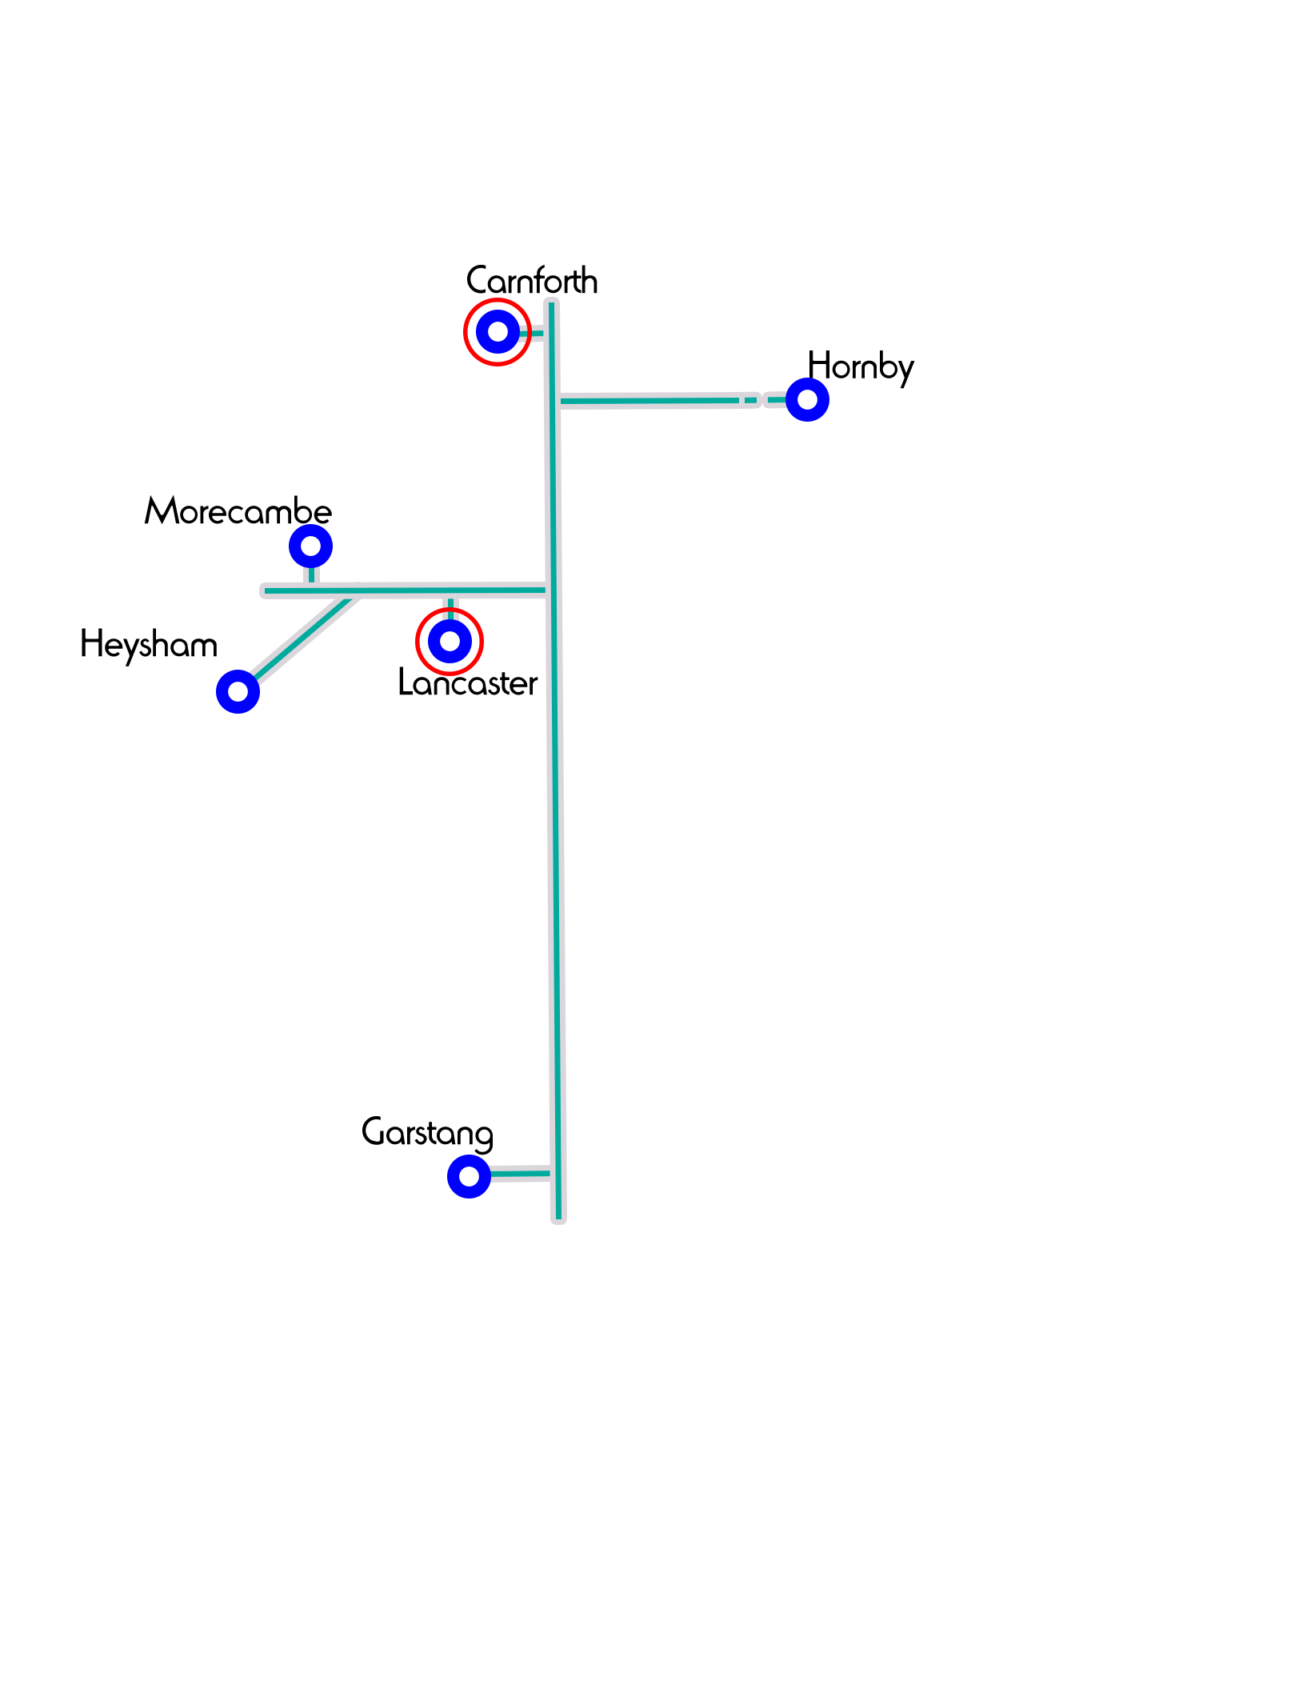

Chair’s report
This last year has been another amazing year as our wonderful team of school’s workers have
taken God’s Word into Primary Schools and High Schools throughout the region with assemblies, lessons, and Jam Clubs. Not to forget church visits and all sorts of other networking events. We praise God for His faithfulness and for the way He has given energy, inspiration, and anointing
to our team. As I think about all that God has done and is yet to do, I am reminded of the
prayer of Jabez when he prayed, “Oh , that you would bless me and enlarge my territory.”
Jabez longed for God to do a special work in his life so that He could enlarge his influence
and make a greater impact for God’s kingdom.
I believe this is what God is beginning to do through the ministry of NISCU as we are looking to expand into areas such as Garstang. In order for this to happen, we need the local church to see the opportunities in their local schools and get involved. Let us rise to the challenge and pray that together we will make an impact for God’s glory in our local schools and community. We also want to say a huge thank you to all our faithful prayer and financial supporters who enable this valuable work to continue and flourish.
God bless you for your partnership in the Gospel
Rev Mark Johnstone
(Chair of Support Team)

Finances

Income and Expenditure - For the Year ending 31st December 2016
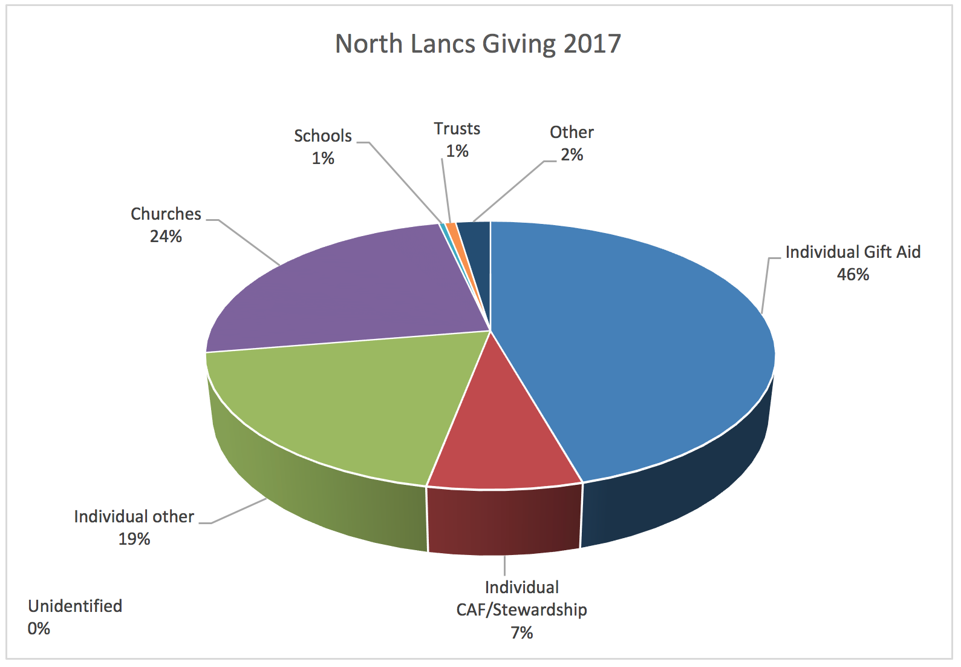
Income | 2016 | 2015
Church Pledged Gifts  Individual Pledged Gifts  Tax Recovery  Miscellaneous Gifts  Local Bank transfer  Total income | £12,157  £36,489  £6,414  £1,762  -  £56,822 | £14,212  £34,827  £4,782  £6,149  £4,306  £64,276

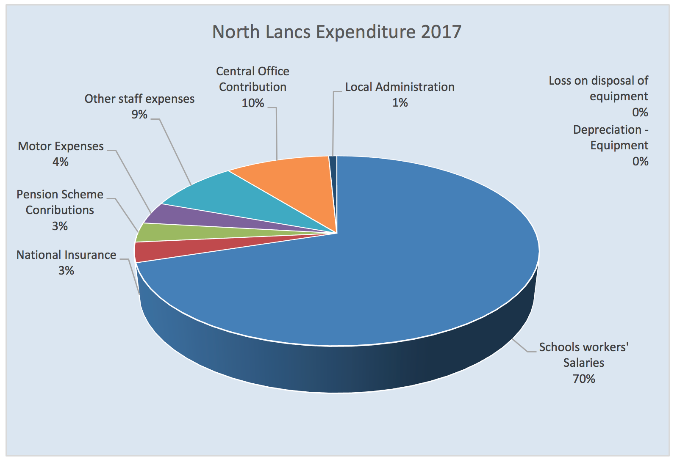
Expenditure | 2016 | 2015
Total Expenditure | £57,718 | £49,680

Balance Sheet as at 31st December 2016

Capital Account | 2016 | 2015
Accumulated Fund | £28,294 | £13,698
Net Surplus for the year | £-895 | £14,596
Balance | £27,399 | £28,294

Work in Schools

This year we… | Primary work | Secondary work
visited schools | 41 (direct contact with 8,500+ children) | 8 (direct contact with 4,800+ young people)
Delivered assemblies (collective worship) | 55 | 21
of which were delivered by our puppet teams | 32
Taught lessons | 187 | 55
Supported lunchtime/after school clubs | 9 (weekly) | 6
Independent school clubs | 6 | 1
other stuff …such as Christmas/Easter roadshows, Prayer spaces…etc | Holy Trinity Day, Prayer spaces,  Walk Through Easter (7 schools) | 2 Crème Egg Quest lunchtimes, 7 Spirituality Days, 1 Listening Service, 1 Multi-faith Day.

Area Support Group: | Area Staff:
Mark Johnstone (Chair), Steven Hewitt,  Jane Callow | Debbie Green  Primary  debbie.green@niscu.org.uk | Diana Stopczyinski  Primary  diana.stop@niscu.org.uk | Jonny Bayes  Secondary  jonny.bayes@niscu.org.uk
Our Story  This year has been incredible for so many  reasons! Our supersize team has been able  to spend more time than ever before in  schools, meeting young people and building  relationships with them, including in several new schools in the Garstang area. We’ve been able to encourage teachers and other school staff in their amazing work. We’ve listened, we’ve talked, we’ve answered difficult questions, we’ve brought children into churches and we’ve done all of this for and because of Jesus! None of this is about us, all of it is about Him, but we see it as an immense privilege that He has chosen us to help Him in this work.  Please read on to hear a few highlights from each of us about the good things God has enabled us to do this year! |  | Rachel Carling  Carnforth - Intern  rachel.carling@niscu.org.uk | Lauren Stockton  Lancaster - Intern  lauren.stockton@niscu.org.uk

Further information

If you would like to receive our weekly prayer bulletins or periodical newsletters, please email jonny.bayes@niscu.org.uk
If you would like to see what we do each week, then visit our website www.niscu.org.uk/nlancs and you will see our diary.
If you would like to support us financially, either go to https://niscu.org.uk/home/giving/, or email ruth.robinson@niscu.org.uk.

Debbie Green

“God appointed us … to receive salvation through our Lord Jesus Christ. He died for us so that, … we may live together with him. Therefore encourage one another and build each other up…” 1 Thess 5:9-11

I am encouraged! This year God has blessed and expanded our ability to support schools. We have seen a rise in demand for lessons and launched into creative new ways of connecting schools to local churches. In our new patch - Garstang - relationships have grown, including church leaders meeting to pray about the way ahead and six new schools opening their classroom doors. Blackburn Diocese and Bishop Geoff made it possible for us to produce resources on Luke’s gospel, used by thousands of children in Lancashire. Plus, alongside Diana and myself, we have continued our work with Sarah Dodd and Lou Mosey, as well as welcoming Jonny, Trev, Lauren and Rachel to the North Lancs team this year.
It has been a year of conferences – sharing resources with the Heads and Clergy in Blackburn Diocese as well as Carlisle; vision casting at Landmark & Newton Rigg; building stronger church links with an Ambassador Evening and meetings with church leaders. I’ve enjoyed sharing resources and ideas with S.U. and Oxford Schools’ Chaplaincy. After two days of training in Birmingham we are now able to support RE co-ordinators as they adjust to a new, Bible-based RE curriculum for Understanding Christianity.
Whilst supporting more schools and staff I have also felt God sending support for us: through prayer groups, our wonderful committee, team days and Retreat. The twenty church visits this year gave me opportunity to thank encouragers and endeavour to inspire more friends to pray, go and give. Nick’s leadership enables our amazing team to build in exciting new ways on the good foundations NISCU has laid and Pam faithfully cheers us on.
The NISCU family (that includes you if you are taking the time to read this) encourages me hugely. Praying with Head teachers and advising staff is both a privilege and humbling. The children who proudly declare that they follow Jesus to their classmates often fills up my heart and my eyes. I am encouraged because God is so evident in our schools. As one little girl called across the playground to her mother, “We’ve been learning all about Jesus.” I give thanks that as we teach children Bible truths, we can also continue to learn all about Jesus for ourselves – all about His never failing love, provision, mercy, compassion, encouragement and strength.

Diana Stopczyinski
I have had another very enjoyable year with NISCU and have been really encouraged as new doors continue to open and relationships grow with schools and churches. My focus in North Lancs is taking Christianity lessons in to the primary schools and this past year I have taught lessons in at least 26 schools in the area. I also continue to lead clubs at Skerton St Luke’s, Grosvenor Park, Lancaster Road and Trumacar and help at the Ridge Jam Club.

Being part of the Christmas Puppet Roadshow which visited 29 primary schools in the area was really special, giving us the opportunity of sharing the ‘true’ meaning of Christmas with hundreds of children. Being the narrator I get to see the smiling, excited faces of the children in the audience.
Partnering with various churches for the ‘Walk Through Easter’ and hearing how the experience had impacted the children who visited, was another special and blessed time. We had feedback from the children which included;
“I learned that I could take my worries to God” and,
“I learned that Easter isn’t just about Easter eggs.”
Also hearing from head teachers how much they appreciate the visits from NISCU.
“You bring exciting lessons that engage the children and help them to think about how the teaching in the Bible applies to them.”
I am looking forward to another year relying on God’s guidance and working with the rest of the team, finding out where we can best serve the local schools.

Lou Mosey
The puppet roadshow is usually the annual highlight of my NISCU year, but when we pioneered the 'Walk Through Easter', I was able to use my creativity as part of the team effort to produce something new and profoundly effective. The groups I led through it were engaged and many of them were moved as they encountered the story in such a visual and active way. My other Easter highlight was being involved in the Creme Egg Quest at LGGS. Most of the questions were more than cerebral and it was great being in a group with one of the 6th formers to give a Biblical perspective (peppered with experiential insights) on topics that people brought to us. It was really well organised and staff response to the event was positive.
Such feedback on NISCU lessons and seasonal specials I have been involved with always makes my heart glad. Recently I did a lesson on forgiveness and was told by the teacher before I entered the classroom, 'the kids are bored with Christianity, it switches them off'.......the thank you email from the teacher after the lesson said 'it was absolutely the right pitch and the children were very interested in what you had to say.'

Jonny Bayes
Before I started as North Lancs’ High Schools worker I remember thinking that 8 schools was a lot for one person to try and ‘look after’, and I imagined that I might get into half of them by the end of my first year. Well, in one sense I was right, but throughout this year I have visited all 8 and taught lessons in 7 of them and as a team we have had been in all 8 schools, most on a weekly basis in some form. As I expected I have focused my efforts on a few schools (the ones who jumped at the chance of having niscu in) which has led to some of my highlights.
Morecambe High School have been particularly excited by what niscu can offer, inviting me in to teach 4 blocks of lessons (2 each with Y9 and Y7) the last of which (on ‘Sin and Salvation’) only happened because the students asked to have me back. We also have plans to start a Listening Service there in the autumn.
Central High school has also provided several highlights. A few years back the CU there had slipped to just 1 person, but by midway through the autumn term we had more than 20 yp attending 2 separate CUs. The new group of year 7s have been a particularly exciting bunch who have kept coming faithfully. Two of them have also started coming to a Friday night youth club that I help to run and shown hints of faith. Through connections with Central I also taught lessons on ‘Living the Christian Life’, which has become a regular topic at several schools over the year – an excellent chance to talk openly about what it really means to be a Christian and the importance of the Gospel!

Sarah Dodd
A year of filling in here and there has slowly developed into a much more focused plan of action. In the autumn term, I did some lessons with my picture book, ‘Legs’, and took the ‘Joseph’ lesson to Year 2 at Ellel, as well as two full afternoons at St Joseph’s, helping with their RE week and focusing on the Bible from Reception to Year 6. Then, of course, it was Christmas and the Puppet Roadshow! Technical difficulties, coughs and colds didn’t dim our enthusiasm and it was a privilege especially to take it into Moorside for the first time.
In the spring term, I was pleased to go into Cawthorne’s Endowed School at Abbeystead for the first time, where I met every single child from Nursery to Year 6, as well as the acting head and most of the staff. Following this The Walk Through Easter was the main highlight of the term. It proved to be such a valuable and interactive way to clearly show the events of Jesus’ death and resurrection to many children and staff in a short space of time.
I have now been given responsibility, along with Diana, for six village schools: Quernmore, Dolphinholme, Ellel St. John’s, Thurnham Glasson, Abbeystead and Cockerham. I have already planned and resourced a brand-new lesson on ‘The Treasure in the Field’ to complement Ellel’s Year 5 RE work, and will be delivering the Y6 transition lesson to Ellel, Thurnham Glasson, Quernmore and Dolphinholme. In addition, I will be taking my ‘Legs’ lessons to Reception and KS1 at Ellel (showing how God cares for us even though we can’t see him) for their Spirituality Day, and planning some new lessons on the meaning of worship to all the children at Thurnham Glasson. This new, tighter focus is already enabling me to make new relationships, which will only be strengthened as I visit these six school much more regularly. Pray in particular that I will be able to be of service to Abbeystead and Cockerham.

Lauren Stockton
This year I’ve witnessed and heard so many wonderful things that I wouldn’t have believed if I’d not seen them myself. I’ve witnessed children as teeny tiny as 2 and 3 realise that Jesus died for them and loves them no matter what. I’ve helped children who otherwise might not hear the Bible to hear it and then been asked if we could sell Bibles at their school fair. I’ve seen a Penguin puppet (Ethel is her name) be an integral part of retelling the Christmas Story - who knew that could happen?! Only with NISCU, as God’s beautiful feet, could any of this be possible!
I’ve be challenged, I’ve grown, I’ve been physically and prayerfully supported by teams and been blessed by the children who I’ve taught in ways I’d never have imagine possible a year ago. I’ve learnt from the children in each school a different lesson and the affects will be life-long. They’ve taught me to laugh, to pray with abandonment, they’ve taught me to sit still and challenged my faith with their questions. I’ve loved every second of every day this year.
I’m sorry I don’t have any facts and figures for you as I’m not a mathematician or a stats person. But I love a good story! I think it stems from my University training! So, if you do want to hear more about how God has been working in schools this year with me as his hands and feet please come and grab me…I have stories a plenty that I’d love to share.
But of course, this year for me wouldn’t have been possible without your vision to have us as interns. Thank you to you all for giving a 24-year-old girl with a heart for Jesus and a passion for children’s ministry a chance. North Lancs the biggest thanks goes to you for adopting me into your family. It’s been a joy and I hope I’ve done you proud.

Rachel Carling
This past ten months has been the most amazing experience of my life, being able to see all the incredible opportunities we have in schools and churches to really bring God to the next generation of this world. I have been involved in so many amazing things this year and it’s hard to just choose one.
My year began with meeting all the head teachers in the Carnforth area and putting in place anything that they could use help with. Over the year I have regularly attended Christ Church Carnforth [helping out with readers, RE lessons and anything else they needed] , Halton St Wilfred’s [helping to run the Jam club] , Warton St. Oswald’s [helping out with RE lessons] , Bolton Le Sands Primary School [running the Bishops Bible Challenge as lessons] , Lancaster Girls Grammar [running the CU alongside Lauren] , Central High School [helping to run the CU alongside Jonny].
The highlights of the year would have to be the Christmas puppet roadshow, being able to narrate the play meant I had the privilege of seeing all the children’s faces as they took in the amazing story of Jesus birth; planning my own prayer space day for Christ Church Carnforth, using the church the school is linked with and seeing all my planning come together resulting in an amazing day of children really digging deep into prayer, reflecting, forgiveness and being sorry; and finally the Walk Through Easter where we walked children station to station through the story of Easter. To have been a part of all these amazing events and assemblies and lessons has been a true privilege and I look forward to seeing what next year has in hold for us all.

