How to make ‘lost’ stones
Make sure you ask a grown-up before you use any stones for this.
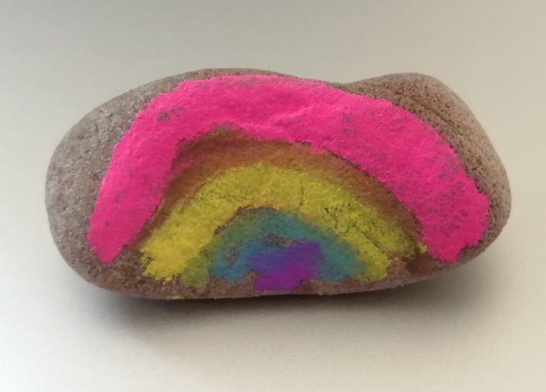
- Clean the stone you are using.
- Wait for it to dry.
- Using chalk or washable colours draw your rainbow/sheep/other picture.
- Write the word Hope or Valued on the back of your stone

Done!!

Next time you go out for exercise take your stone and put it somewhere (safe) that someone else might find it.

Maybe you can look for other people’s stones too if you know anyone else who has done it
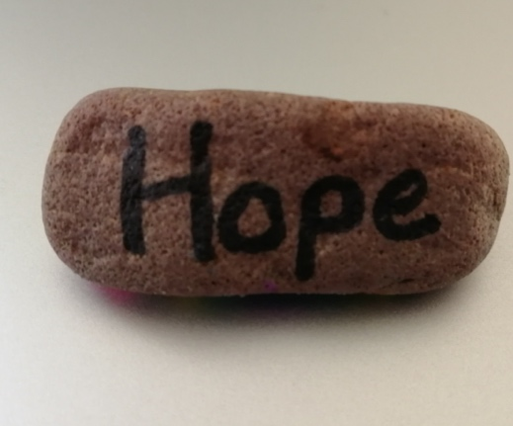

Remember that you are loved, and valuable to lots of people, including God, and let that help you have hope.

